SCAS WA3D Field Tournament
6th /7th June @ Bilsington Priory Kent.
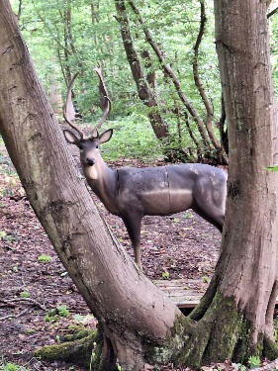
Once again Ashford Archers were our hosts for the 2day WA3D tournament. The club incorporated the SCAS, English and Kent competitions into their shoot, providing a challenging course with good use of the terrain, light and targets to bring out the best in the 80 competitors that attended.
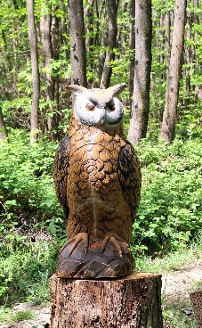
The weather on the first day was wet drying out to spells of soggy adding to the challenge, day 2 was dryer but the ground was stodgy and slippery from the day before.
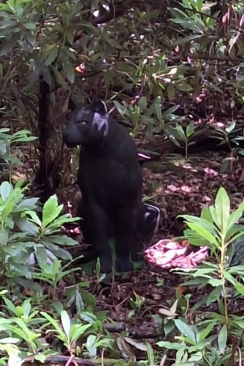
Despite this some very respectful scores were shot along with several personal bests, link to the results below. The feedback from the Archers was all positive with a common comment “that black panther is a beast of a shot”
Thank you to Ashford Archers, the Work party, the Judges and all the Archers for making the weekend a great success.

Bob Beaney
SCAS Field Rep
https://ianseo.net/Details.php?toId=28729

