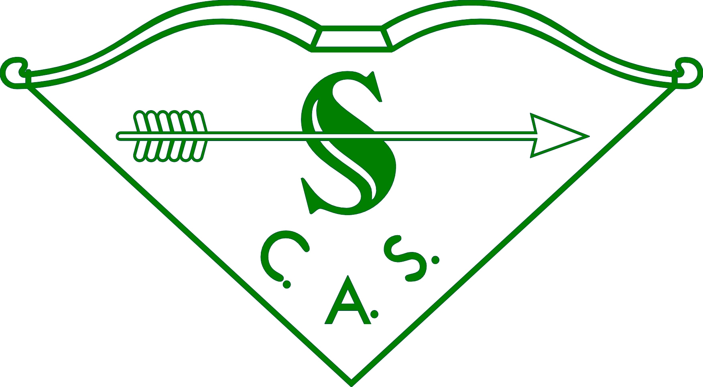

SOUTHERN COUNTIES ARCHERY SOCIETY

COUNCIL MEETING – 14 January 2023

SUMMARY of BUSINESS

The meeting, conducted by Zoom, was well attended.

1. SCAM:

Trophies have been reviewed and two new ones purchased to replace missing ones.

2. WINTER POSTAL LEAGUE:

8 counties are currently involved, including 43 barebow, 49 compound and 100 recurve archers, with a very pleasing 81 Juniors. Some high scores have already been recorded.
Medals will be awarded to all winners this year.

3. AGB BAN on all tournaments clashing with the Nationals 23-24 September:

There was a lengthy discussion on this ban, which had upset several clubs’ arrangements. It appears to have been imposed with no consultation.
Bedfordshire has applied to AGB for the ban to be lifted; it is due for discussion at a meeting next week.
The wider picture is that AGB Competitions Officer is concerned about the large number of WRS applications being received, in cases where a FITA Star &/or Rose Award status was formerly appropriate. Members observed that clubs are driven to apply for WRS in order to attract archers seeking national ranking, and thus boost financial viability of tournaments. Equally, there is a need for tournaments appropriate to new archers and those not currently seeking national ranking. Indeed, there is an opportunity to set up WRS-style tournaments to give experience of field layout and procedure for those who might wish to progress to a real WRS tournament.
It was noted that AGB announced a complete review of its Competitions Policy some time ago, but this is yet to materialise.

4. JUNIOR TOURNAMENT TOUR

Rod Brown and Michael Barr had produced an extremely detailed and well researched document proposing a ‘tour’ of junior tournaments through the summer season, culminating in a final (Junior Championships) at the end. Junior archers will be encouraged to attend at least three of the normal club/county junior tournaments which agreed to participate in the tour, and would gain points for attendance and performance through the season. Details are available elsewhere on the website, and will be refined before promulgation to counties and clubs.

5. AGB REGIONAL DEVELOPMENT OFFICER

The post is currently vacant. SCAS Trustees will be in discussion with AGB about its future.

6. TOURNAMENTS

Details of the INDOOR (4-5 Feb) and CLOUT (04 Jun) are on the website.
There are still no viable offers for either of the Inter-Counties, mainly due to lack of working party volunteers.

7. JUDGING

SCAS Judges have enjoyed another busy and successful year, although overall numbers are slightly depleted. There was a well-attended and informative Conference.

8. GRANTS

The meeting agreed to double the amount available for Academy attendance to £200.

9. AGM – Sat 15 Apr – Brown’s Covent Garden

Nominations are required for:

President’s Medal – awarded to any archer who has given outstanding service to the Region in any capacity (shooting, administration, judging, coaching, etc). Nominations due by 28 February

All Officers and Officials, especially President and Lady Vice-President whose terms of office end this year.

