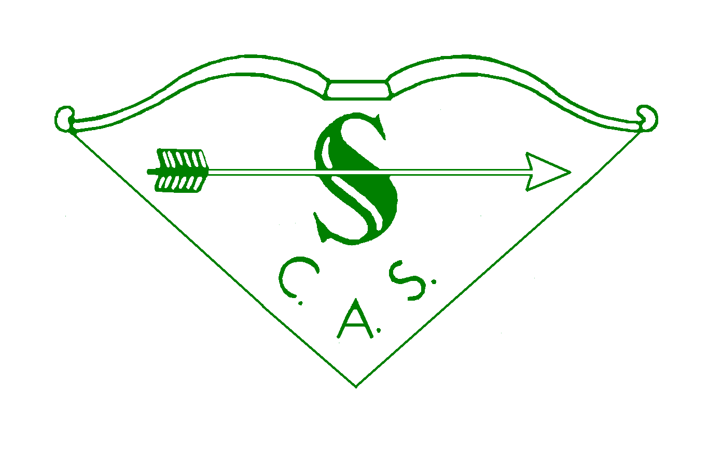
SOUTHERN COUNTIES ARCHERY SOCIETY
Group Grant Application Form

Group Information
Group Name |  | Type of Organisation (Club/County etc)

Address of Group
 |  | AGB Club Number (if applicable)

Number of Years affiliated to SCAS

Representative’s Information
Title |  | Forename
Surname |  | Archery GB Number

Address
 |  | Post Code
Contact Telephone No 1 |  | Contact Telephone No 2
Email Address |  | Position in Group

Grant Information

Purpose of Grant (include as much detail as you can)

Details of how the Grant will help the Group and the wider SCAS Community

Total cost to the Group for the project and how this amount is made up

Amount applied for and what it will be used for

Details of how the rest of the Project will be funded

Please attach any additional information that helps the application.

Additional information

Details of any other SCAS Grants or Loans applied for

Any additional information you would like to provide

Conditions

- All applications must be submitted with supporting documentation showing details of the Project. Failure to supply the additional information will cause the application to be rejected.
- If any further information is required to reach a decision this will be requested. Failure to supply the additional information will cause the application to be rejected.
- If the Group fails to complete the Project the Group will need to re-pay the Grant in full in a mutually agreed timescale.
- Grants may have certain conditions attached to them, for example that SCAS has access to the project for a certain amount of time. If these conditions are not adhered to then some or all of the grant may need to be repaid.
- All application must be made electronically to grants@scasarchery.org.uk
- If successful the Group is requested to thank SCAS along with their other sponsors and to feed back information on the progress of the Project.
- Full details of the Grant process including Loan Limits can be found on the Southern Counties website (http://www.scasarchery.org.uk/Web/index.php/Finance_and_fees#policies) in the Grant and Loan Policy, or email grants@scasarchery.org.uk

SIGNATURE

Signature

Name

Date

(For Awards panel use)
Date Received |  | Approved | Yes No
Date Responded |  | Reference | _____ / _____

