|  |  |  |  |  |
| --- | --- | --- | --- | --- |
| Hampshire Open Indoor Archery Weekend 2021  Incorporating Hampshire County Championship & SCAS Regional Championships  Prospectus | | | | |
| **Hampshire & SCAC Regional Indoor Championships 20211 Hampshire Indoor Championships 2020** | | | | |
| Location | **Fleming Park Leisure Centre, Eastleigh, Hampshire SO50 9NL** | | | |
| Round | **WRS WA Combined (Sat) & UK Portsmouth single round (Sun)** | | | |
| Dates | **9th & 10th October 2021** | | | |
| Guest of Honour | **tbc** | | | |
| Judges | **Chairman of Judges:** | **Paul Richards** | **Director of Shooting:** | **Phil Collins** |
| **Assisted by:** | **Lee Miller, Nick Nicholson, Georgina Cutts, Maurice Berridge** | | |

|  |  |
| --- | --- |
| Registration | Registration from 8am on Saturday WA Combined. Registration from 8am on Sunday for session 1 & 11.30am for session 2. Please have valid membership cards available at registration. |
| FEES | **£22** for Saturday 9th Oct - WRS WA25m & WA18m Combined  **£16** per session Sunday 10th Oct –Portsmouth.  Sat & 1 Session Sun **£36**  **Please send/email in an entry form for each day (but you can use 1 cheque or 1 BACS transfer) Closing date 1st Oct 2021.No refunds after the closing date.** |
| Event Timings | There will be only 1 session on Saturday 9TH Oct ;  WA25m– All bowstyles - Assembly 9.00am followed by practise  Equipment inspection will take place during registration, break/ lunch for change of distance for the WA18m.Restart at 1.00pm approx.  There will be 2 sessions on Sunday 10th October –Portsmouth  Equipment inspection will take place during registration  Session A- All bow styles; Assembly 9.00am followed by 2 ends of sighters for the Portsmouth  Session B- All bow styles; Assembly 1.00pm followed by 2 ends of sighters for the Portsmouth  The awards ceremony on the Saturday and Sunday afternoon |
| Event Format | Saturday  WA Combined;All Recurve and Compound archers will shoot on a vertical 3-spot 60cm face, 2 archers per face & individual vertical 3-spot 40cm face  All Longbow & Barebow archers will shoot on a full WA25m 60cm & WA18m 40cm face  Sunday  Portsmouth; All Senior Compound archers & ***Juniors U18 & U16***, will shoot on an individual vertical 3-spot 60cm face  All Recurve,Longbow & Barebow & ***junior compound archers U14 & U12***, will shoot on a 60cm full face  All bosses will be layered foam  All depended on **Covid-19** regulations at the time |
| Awards | Saturday; Medals for 1st, 2nd & 3rd place, Gents, Ladies & Juniors; Compound, Recurve, Longbow or Barebow depending on number of entries for the combined score.  Sunday; **County Champion & SCAS Regional Champion**. Single Round only; Trophies will be awarded to the highest placed archers. Ladies, Gents, Junior Ladies and Junior Gents per bow style per age group. Medals for the minor according to number of entries.  **Hampshire**- Team of 3 Recurve (mixed gender) Compound, Longbow & Barebow 2 archers and 3 Juniors any bow style not in another team (any gender) Medals according to entries for the minor places  **SCAS County Team awards**-Team of 4 Recurve, Compound & Longbow team of 2 archers. All awards will be taken from the first score (should you shoot a second session) for both Championships. |
| SCAC Current Trophy Holders | Please can I remind the SCAS Trophies holders, to return the trophies to the Tournament Secretary on the day of the shoot or prior. |
| Dress Code | Please refer to the Archery GB Rules of Shooting 307  Please wear sports shoes in the hall. |
| Drugs Testing | Archers competing at record status tournaments may be liable for drugs testing.  Competitors who are approached to give samples must comply.  Non-compliance will be treated as a positive result.  Parents / Guardians must sign the relevant box on the entry forms giving consent for junior archers (Under 18’s) to be drug tested if approached. |
| Refreshments | Refreshments are available at the venue. No hot food/ drinks to be taken in the sports hall |
| Photography | In line with the recommendation in the Archery GB Safeguarding Policy, those who wish to take photographs or video at this event are to register with the Tournament Secretary on arrival.  Unauthorised photography is not permitted. |
| Special Notes | Archers who are unable to get to the target should arrange for an assistant to aid in scoring and arrow collection. |
| Parking | Free parking will be available at the venue |
| Dogs | No dogs permitted in the hall |
| Smoking | Please use the designated smoking area provided, including E cigs |
| Raffle | There will be a raffle on the Sunday before the prize giving! |
| Tournament Secretary | Mrs Carla Piper –41 Oakley Road,Wilton,Salisbury,Wiltshire SP2 0FA  [cpiperarchery@gmail.com](mailto:cpiperarchery@gmail.com) Home number 01722 743476 (after 6.30pm and before 9.00pm) |
| GDPR | **“When you enter competitions the following information may be collected and shared with tournament organisers, scoring systems and other competitors for example target lists and results may be published: First Name, Surname, Gender, Bow style, Date of Birth / Age category, Email, Address, Phone number, Club (and ID), County (and ID), Region (and ID), Round (unless defined by age), Disabled (Y/N), Disability info.”** |
| Liability | *Neither Hampshire Archery Association , Southern Counties A A or Places Leisure and Subsidiaries do not accept any liability or responsibility for any loss, damage or injury however so caused.* |

[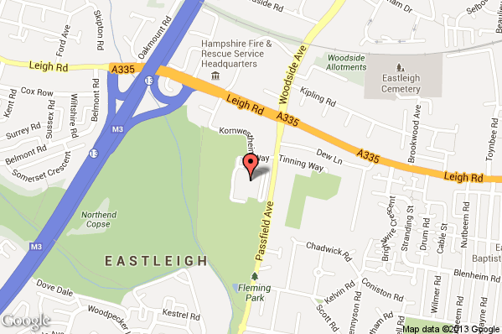](http://maps.google.co.uk/maps?daddr=50.96974,-1.36982%20(Fleming%20Park%20Leisure%20Centre)&hl=en&sll=50.96974,-1.36982&t=m&z=16)

|  |  |
| --- | --- |
| Directions | Places Leisure Centre, Passfield Ave, Eastleigh, Hampshire SO50 9NL- <www.placesleisure.org> |