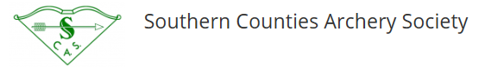

Menu for SCAM 2020
Menu
Wed- 13th | Longbow Day | Chicken Casserole, new pots & vegs | Choc Tart & Crème Fraiche
Thur - 14th | York/Hereford | Roast Beef, roast pots, yorkie pud & veg | Eton Mess
Fri -15th | York/Hereford | Breaded Fish,chips & peas | Treacle Sponge & Custard
Sat -16th | Long National | Spag Bol & garlic bread | Strawberry Cheesecake

As well as the 2 course lunch at £10 per head, the below will also be available:
Breakfast
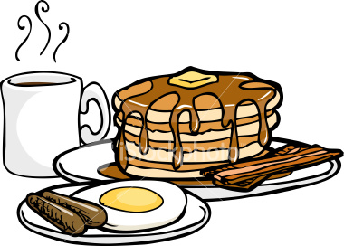
Breakfast rolls, bacon or sausage £3.50 each (Veggie option egg & mushroom)
Lunch time snacks
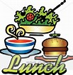
Jacket Pots & 1 filling £5 & 2 fillings £6
Sandwich, soup & crisps £6.50
Hot beverages as priced

