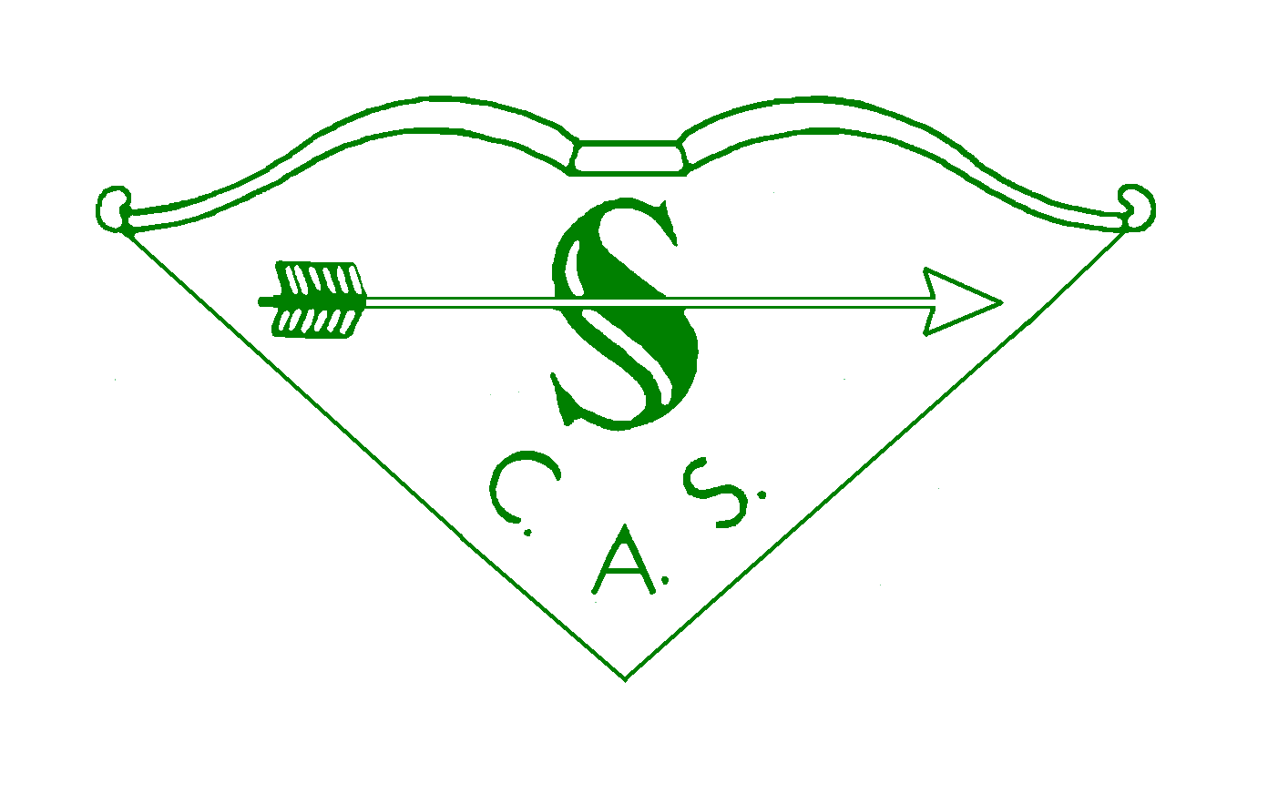
SOUTHERN COUNTIES ARCHERY SOCIETY
Individual Grant Application Form

Applicant Information
Title |  | Forename
Surname |  | Archery GB Number

Address
 |  | Post Code
Contact Telephone No 1 |  | Contact Telephone No 2
Email Address |  | Date of Birth (if under 18)

If under 18 the name and address of parent/guardian
Club Name |  | County

Number of years in SCAS

Event Information (FOR which Grant is being requested)
Name of Event |  | Date of Event
Location of Event |  | Class (Adult/Cadet etc.)

If embargo on team details, date it will be lifted
Discipline of Event (Target/Field/3D etc.) |  | Category (Recurve/Compound etc.)
Capacity in which attending (Archer/Agent/Coach etc.) |  | Organisation you will be representing (Archery GB / England etc.)

Total cost to you of Event and how this amount is made up

Amount applied for and what it will be used for

How will the remainder of the cost be funded?

Please attach proof of your invitation to the Event and any supporting information to show what cost you will incur by attending

Additional information

Details of any other SCAS Grants applied for this calendar year

Any additional information you would like to provide

CONDITIONS

- The maximum value that the Review Panel are able to award is £400 per application, with a maximum of 3 applications awarded in any one calendar year. In exceptional circumstances the limit may be waived by the SCAS Council.
- All applications must be submitted with supporting documentation showing that you have been invited to the Event and supporting information to show what costs you will incur by attending. Failure to supply the additional information will cause the application to be rejected.
- If any further information is required to reach a decision this will be requested. Failure to supply the additional information will cause the application to be rejected.
- If you fail to attend the event you will need to re-pay the Grant in full in a mutually agreed timescale.
- If the applicant is under 18 the application will need to be co-signed by a parent/guardian and if the application is successful, the Grant will be paid to the parent/guardian.
- All applications must be made electronically to scasgrantspanel@gmail.com.
- If successful, the applicant is requested to thank SCAS along with their other sponsors and to feedback how they did at the Event. If sharing on social media, please use the hashtag #SCASArchery.
- Full details of the Grant process including Grant Limits can be found on the Southern Counties website http://www.scasarchery.org.uk/Web/index.php/Finance_and_fees, or email scasgrantspanel@gmail.com.

Using your personal information (GDPR)
The information on this form will be used solely to assess the application. It will be stored on secure online systems and shared with the members of the review panel and members of the SCAS Executive.
Information from this application will only be shared with third parties if essential for completing the processing.
The full information will be stored until after the event is completed or twelve months, whichever is the longer. Summary information, including name of archer, details of event and outcome of application will be retained for statistical purposes.

By signing this form you confirm acceptance of the conditions and the use of your information.

SIGNATURES
APPLICANT |  | PARENT / GUARDIAN IF APPLICANT IS UNDER 18
Signature |  | Signature
Name |  | Name
Date |  | Date

(For Awards panel use)
Date Received |  | Approved | Yes No
Date Responded |  | Reference | IG20_____ / _____

